Date access: 2020-03-10

<http://wjw.beijing.gov.cn/wjwh/ztzl/xxgzbd/gzbdyqtb/202002/t20200201_1622225.html>

From 14:00 to 24:00 on January 31, 17 new cases of pneumonia infected with new coronavirus were added to the city

Date: 2020-02-01 Source: Beijing Municipal Commission of Health

From 14:00 to 24:00 on January 31, 17 new cases of pneumonitis infected with new coronavirus were added to the city, including 11 cases with contact history in Hubei and other provinces, 12 close contacts with confirmed cases, and 7 with existing Hubei The history of contact with other provinces is close contact with confirmed cases, and one case has not yet completed epidemiological investigation. All have been sent to designated medical institutions for treatment.

As of 24:00 on January 31, a total of 156 confirmed cases have been confirmed in the city, including 1 death, 5 discharges, and 150 cases of isolated treatment at designated hospitals. 3 cases in Dongcheng District, 17 cases in Xicheng District, 27 cases in Chaoyang District, 35 cases in Haidian District, 12 cases in Fengtai District, 3 cases in Shijingshan District, 1 case in Mentougou District, 13 cases in Tongzhou District, 2 cases in Shunyi District, 19 cases in Daxing District, There were 12 cases in Changping District, 1 case in Huairou District, and 11 cases came from overseas. No cases have been reported in Fangshan District, Pinggu District, Miyun District, and Yanqing District.

**1月31日14时至24时，本市新增17例新型冠状病毒感染的肺炎病例**

日期：2020-02-01 来源：北京市卫生健康委‍

1月31日14时至24时，本市新增17例新型冠状病毒感染的肺炎病例，其中11例有湖北及其他省份接触史，12例为确诊病例的密切接触者，7例既有湖北及其他省份接触史又是确诊病例的密切接触者，1例尚未完成流行病学调查。均已送至定点医疗机构进行救治。

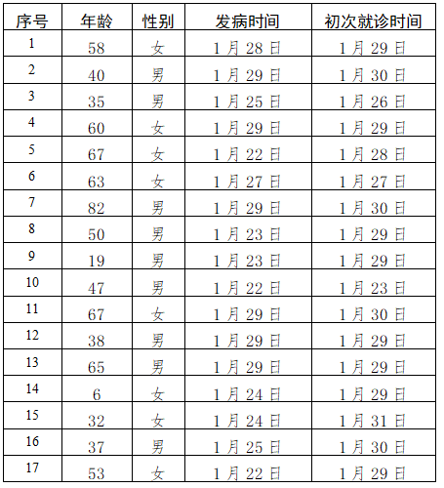

截至1月31日24时，本市累计确诊病例156例，其中死亡1例，出院5例，150例在定点医院进行隔离治疗。东城区3例、西城区17例、朝阳区27例、海淀区35例、丰台区12例、石景山区3例、门头沟区1例、通州区13例、顺义区2例、大兴区19例、昌平区12例、怀柔区1例，外地来京人员11例。房山区、平谷区、密云区、延庆区尚未有病例。